This document details what should be covered in the assignment:

TITLE OF ASSIGNMENT: RECRUITMENT & SELECTION PLAN - GARLAND HOTELS

FORMAT:
- Written assignment with a 2,000-word count (+ or – 10%).
- Style: Passive (objective) voice
Include:
  - Assessment cover sheet including title of assignment
  - Table of contents.

Sample Essay Template
Introduction
Give a brief outline of the main contents of the essay (what you intend to inform the reader of and how you intend to achieve this). Keep it to approximately 150 -200 words. Come up with your own section titles for the following sections or use the ones provided below. You can use sub-headings under each section if you so wish.

Job analysis documentation
This section should very briefly explain how you carried out the job analysis (hypothetically speaking!). You should then include the outputs from this process – namely the Job description for the Graduate trainee role and the Person specification. You may use the template provided for these in class or any other templates you feel are appropriate. You must use the sub headings (A&B) listed below:

- Job Description

- Person Specification

Recruitment Strategy
Describe the approach you are recommending and why. Your job analysis will be relevant here as it will help identify the target market from which you expect to attract your candidates. How easy/difficult will it be to find the right candidates? Evaluate methods of recruitment to determine which you consider are most suitable including consideration of the options for using social media. Will you use a range of approaches or keep your focus more targeted? Consider cost and resource implications of your choices.

Selection Strategy
Describe the approach you are recommending and why. You should explain the approach you plan to use in terms of shortlisting and then assessment of those shortlisted to see if they possess the necessary skills/capabilities for the job. What selection methods/tools will be used? What are your selection criteria and how will you test for them? Consider the cost and resource implications of your choices and weigh these up against the need to ensure you get the best and most talented people for the jobs.

Conclusion Conclude by pulling the strands of the essay together. No new material should be added to the conclusion but ensure you include a brief summary of your recommended approach to recruitment & selection at Garland (150 -200 words).

On the line below the last sentence of the conclusion, put the total word count in your assignment. Information presented in tables or diagrams is not included in the word count

Word count: 2,000

References
Your references (sources used) should be listed on the next page using Harvard Style. List all of the books, articles, journals, etc., (in alphabetical order) that you referenced in this essay.

N.B. Relevant reading material can be found on Moodle and also in the core recommended reading as listed in the module Reading list (in the module handbook). Additional articles are available in the library catalogues and databases and can be retrieved by searching for key words.

Overall it’s not an A+ paper and I’m not sure if this is worth 130 euros. The job title itself is already incorrect. It needs to called and Graduate Trainee Manager as per assignment brief.
This needs to be a 2000 word essay not including the table of contents, the details in the table, and references.
I also need you to add and assume costs for the recruitment strategy. I need you to expand on the answers for recruitment strategy and activities as it’s not strong enough. The point is to make sure that the company/hotel will get a better staff therefore social media wouldn’t be enough for that.
The candidate needs to interviewed properly etc. Please add more methods.
I have added another source - (Resourcing & Talent Management - Stephen Taylor, 7th edition

Notes to bear in mind:

(1). A job description and a separate person specification for the graduate trainee role
(30 marks)
Creating a Job Description
A carefully designed job description will be an essential tool in determining the selection criteria for potential candidates.
Before you put pen to paper and design the job description, consider:
- • the role and responsibilities of the current job-holder
- • the needs of the team the job holder will be working in
- • the aims and objectives of the department and organisation
Once you have done this, use this template to help you draw up a clear and accurate job description.
Job description Template
Component | Description
Job Title | Make sure the job title accurately reflects what the job role is. It should be non-discriminatory, e.g. sales- person, waiting staff.
Location | Where the role will be based e.g.: Dublin
Purpose of the role | Overall purpose of the role and relationship to the aim of the organisation. Why and in which context this job exists, e.g. ‘to provide administrative and secretarial support to six sales executives who work remotely in regional areas around Ireland’
Tasks & Responsibilities | List main tasks the job holder will be required to perform (as many as you can think of).  Also highlight any Occasional tasks or Secondary duties.  Position of job in organisational structure (To whom job-holder is accountable) Also any. Subordinate staff they have (i.e.: people who report into them)  Also list other responsibilities of the job-holder. E.g.: finance/ budgets, equipment etc
Work environment | Features of the work environment that should be highlighted e.g. static, mobile, outdoor, office based, hazardous etc.  What contact job holder will have with others e.g.: external clients, other departments, members of the public etc
Training and education | Training that’s required for job-holder. Educational courses or qualifications normally associated with the job which you expect the job holder to undertake. (Could also list on the job training that will be required )
Conditions of employment | Salary, benefits, etc. Hours of work.
Job circumstances | Any unusual aspects of job commonly accepted as pleasant/unpleasant/easy/demanding, etc. E.g.: requirement to work overtime or weekends as needed
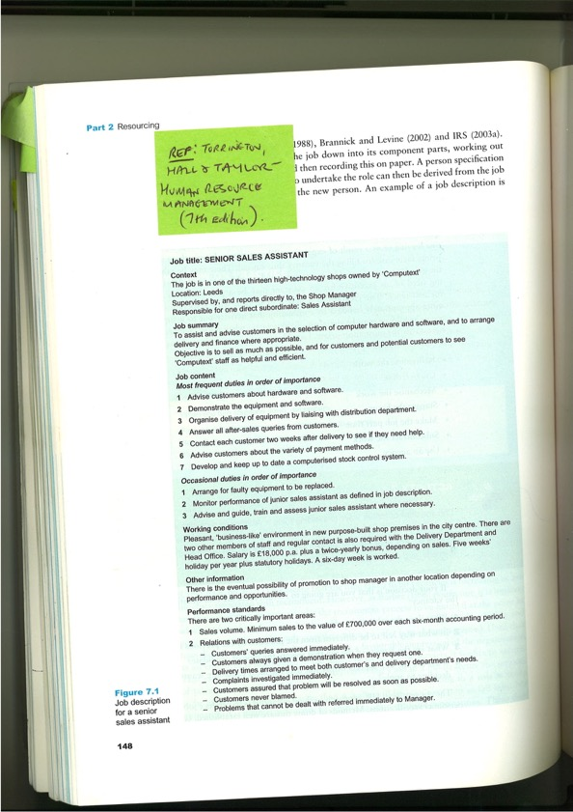

Job Spec (THIS LAYOUT) NEEDS TO BE USED FOR THE ASSIGNMENT
 | Essential | Desirable
Qualifications
(Education/training)

Knowledge
(e.g.: sector knowledge, specific technical expertise)

Skills/competencies
(work related personal attributes e.g.: teamwork, leadership, communication skills, etc
Previous Experience

Recruitment Strategy
Describe the approach you are recommending and why. Your job analysis will be relevant here as it will help identify the target market from which you expect to attract your candidates. How easy/difficult will it be to find the right candidates? Evaluate methods of recruitment to determine which you consider are most suitable including consideration of the options for using social media. Will you use a range of approaches or keep your focus more targeted? Consider cost and resource implications of your choices.

Selection Strategy
Describe the approach you are recommending and why. You should explain the approach you plan to use in terms of shortlisting and then assessment of those shortlisted to see if they possess the necessary skills/capabilities for the job. What selection methods/tools will be used? What are your selection criteria and how will you test for them? Consider the cost and resource implications of your choices and weigh these up against the need to ensure you get the best and most talented people for the jobs.

